Set 7 Customer Demographics Analysis
Dataset: Customer Demographics
Customer ID Age Gender Income (in $)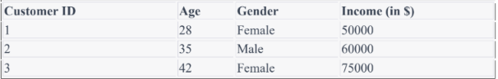
- Create a bar chart to visualize the distribution of customer ages. Label the axes and title the chart.
Aim
To create a bar chart in R to visualize the distribution of customer ages.
Procedure
- Create the customer demographic dataset.
- Store the customer ages in a variable.
- Use the barplot() function to create the bar chart.
- Add appropriate X-axis, Y-axis labels and chart title.
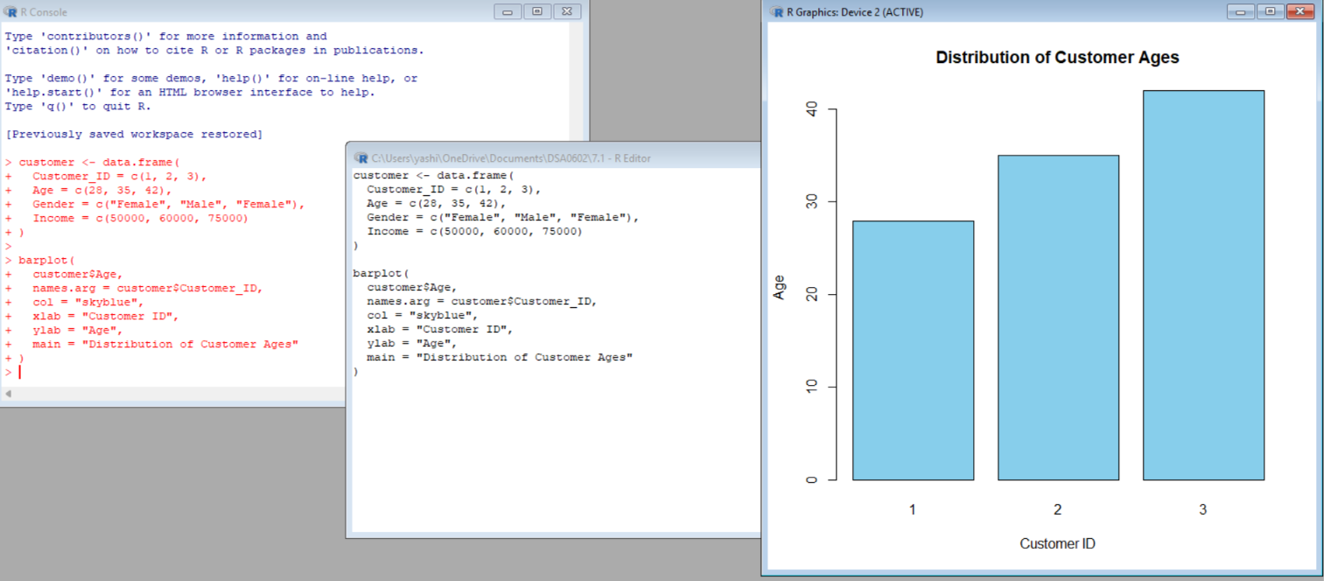
Result
The bar chart successfully displays the ages of the three customers. The customer ages are 28, 35, and 42 years.

2. Generate a pie chart to represent the distribution of customers by gender.
Aim
To create a pie chart showing the distribution of customers according to gender.
Procedure
- Create a frequency table for the Gender variable.
- Use the pie() function.
- Add labels and colors to the pie chart.
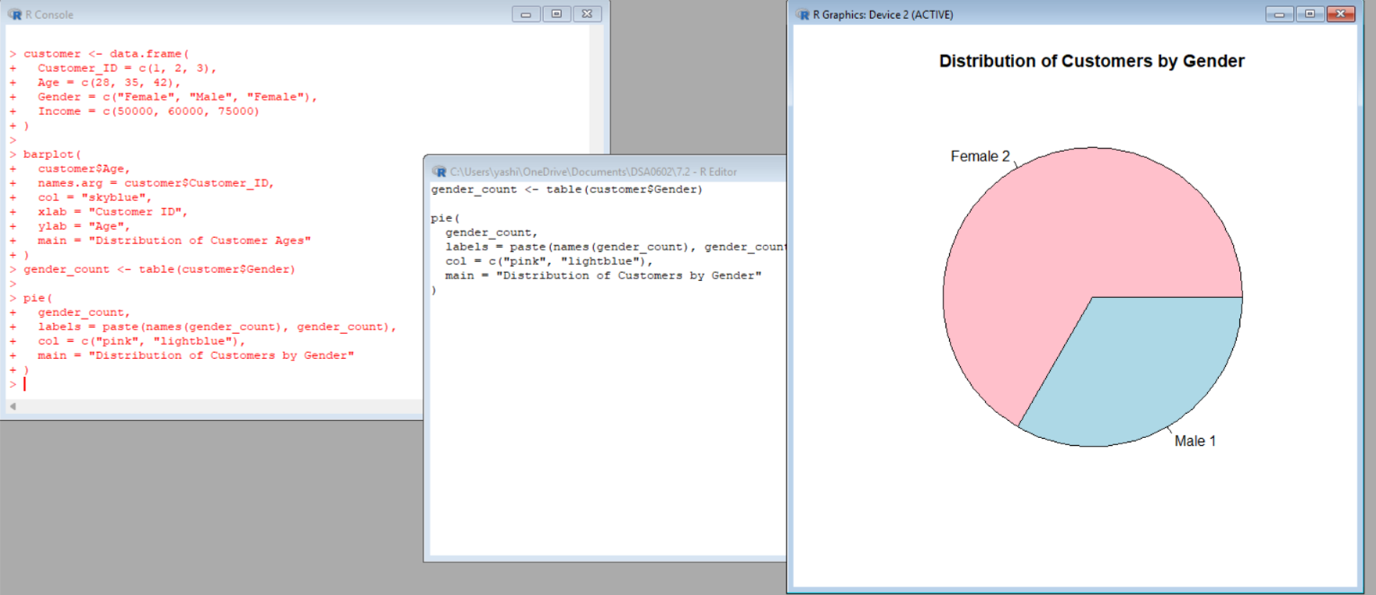
Result
The pie chart shows that there are 2 Female customers and 1 Male customer.
3. Build a table to show the demographic information for each customer. Label the table elements.
Aim
To create and display a table containing the demographic information of each customer.
Procedure
- Create variables for Customer ID, Age, Gender and Income.
- Combine them into a data frame.
- Display the data frame using the print() function.
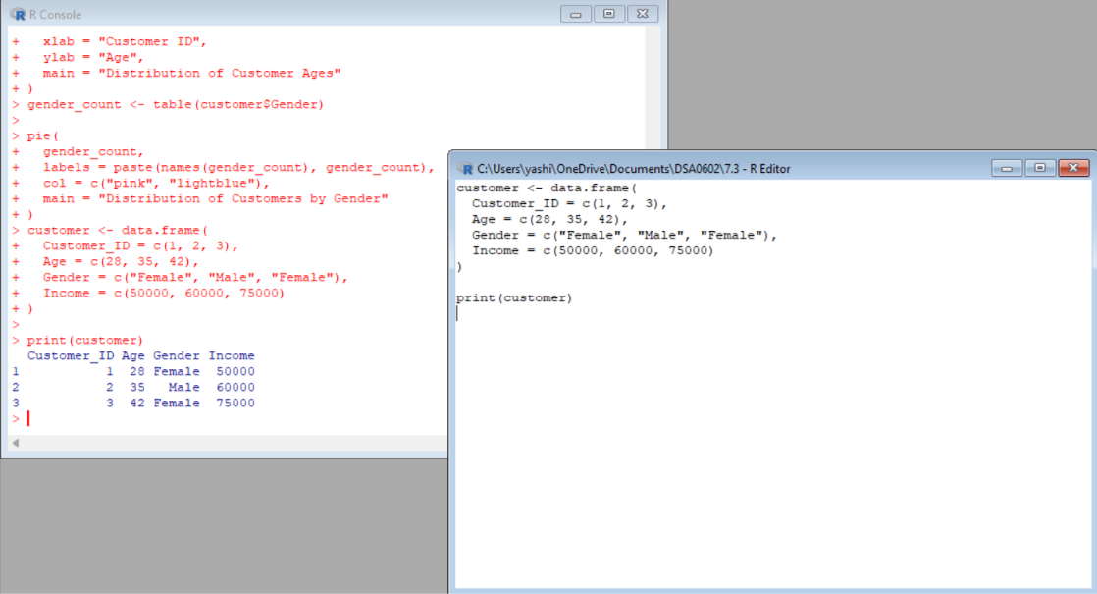
Result
Customer ID | Age | Gender | Income ($)
1 | 28 | Female | 50,000
2 | 35 | Male | 60,000
3 | 42 | Female | 75,000
The table successfully displays the demographic information of all customers.

- Develop a Tableau dashboard combining the bar chart, pie chart, and the table for interactive exploration of customer demographics.
Aim
To create an interactive Tableau dashboard combining the age bar chart, gender pie chart and demographic table.
Procedure
- Open Tableau.
- Import the Customer Demographics dataset.
- Create a worksheet for the Age Bar Chart.
- Create a worksheet for the Gender Pie Chart.
- Create a worksheet containing the Customer Demographic Table.
- Create a new dashboard.
- Drag all three worksheets into the dashboard.
- Add filters if required.
Result
A Tableau dashboard is created containing the customer age bar chart, gender pie chart, and demographic table, allowing interactive exploration of customer demographics.

Set 8 Employee Performance Analysis
Dataset: Employee Performance
1.Create a line chart to visualize the performance trend of employees over time. Label the axes and title the chart.
Aim
To create a line chart showing employee performance scores according to years of service.
Procedure
- Create the employee performance dataset.
- Store Years of Service and Performance Score.
- Use the plot() function.
- Set type = "o" to display both points and connecting lines.
- Add suitable labels and title.
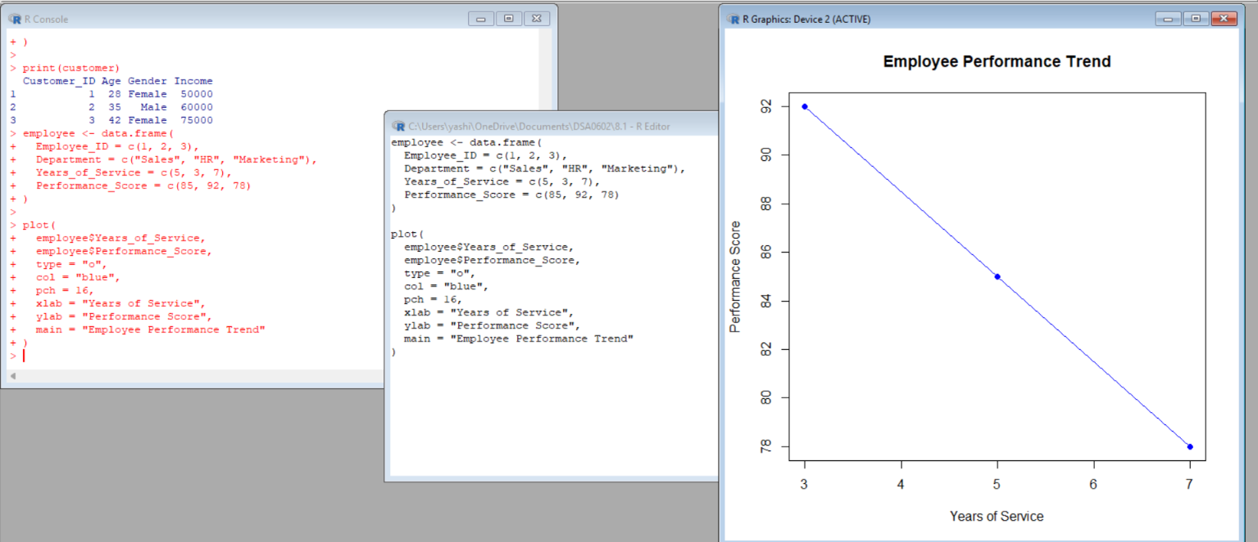

Result
The line chart successfully displays performance scores against years of service. The performance scores are 85, 92, and 78 for employees with 5, 3, and 7 years of service respectively.

2.Generate a bar chart showing the distribution of employees across different departments. Label the chart elements.
Aim
To create a bar chart showing the number of employees in each department.
Procedure
- Create a frequency table of departments.
- Use the barplot() function.
- Add axis labels and a suitable title.
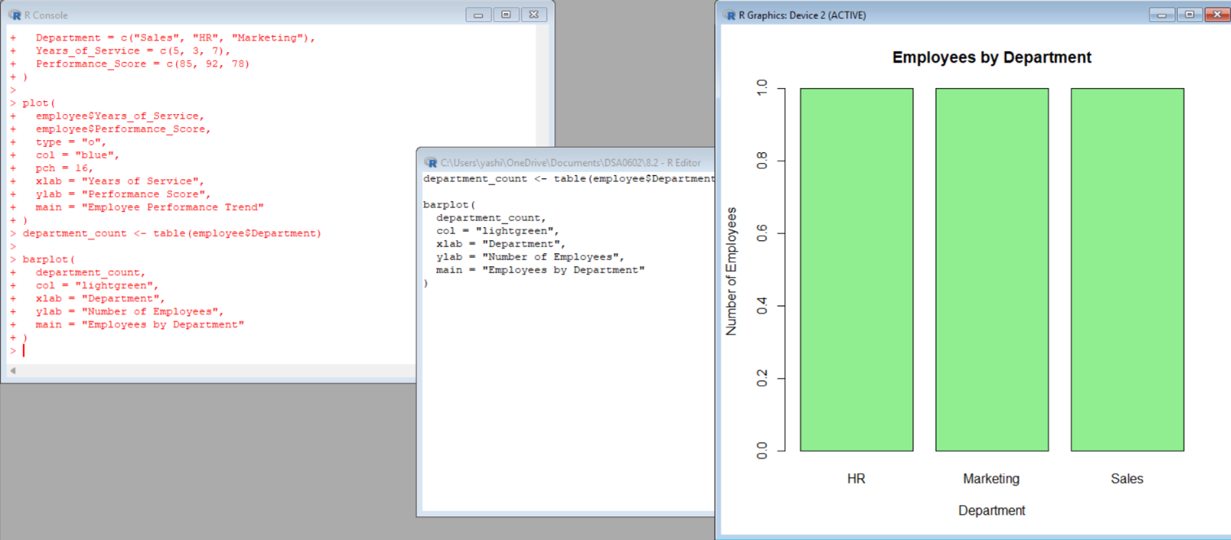
Result
The bar chart shows the distribution of employees across Sales, HR, and Marketing. Each department has one employee.
3.Build a table to display the performance data for each employee. Label the table elements.
Aim
To create a table displaying employee ID, department, years of service and performance score.
Procedure
- Create the employee data frame.
- Store all employee information in appropriate columns.
- Display the data frame.
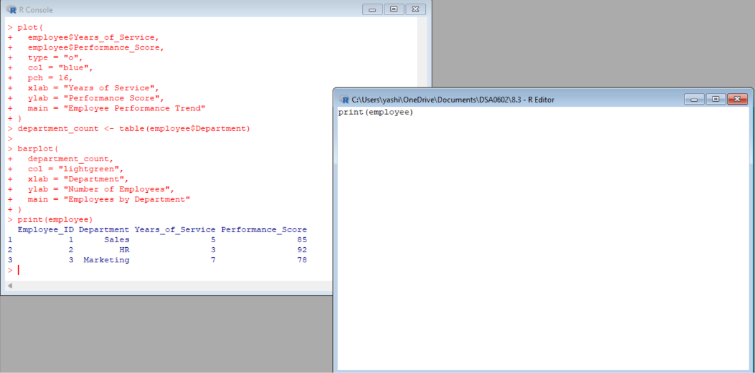
Result:
The table successfully displays the performance information of all employees.

4.Develop a Tableau dashboard combining the line chart, bar chart, and the table for interactive exploration of employee performance data.
Aim
To create an interactive Tableau dashboard combining employee performance visualizations.
Procedure
- Import the Employee Performance dataset into Tableau.
- Create a Performance Trend Line Chart.
- Create an Employees by Department Bar Chart.
- Create an Employee Performance Table.
- Create a new dashboard.
- Drag all three worksheets into the dashboard.
- Add filters for Department or Employee ID if required.

Result

The Tableau dashboard successfully combines the performance line chart, department bar chart, and employee performance table for interactive analysis.
set 9
Dataset: Online_Learning_Activity.csv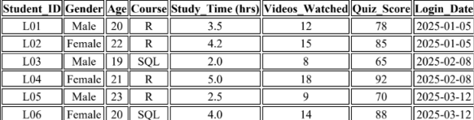

1.Import the dataset in R. Plot a histogram for Quiz_Score. Draw a boxplot of Quiz_Score by Course. Add title and labels. Interpret student performance.
Aim
To import the Online Learning Activity dataset into R and analyze quiz-score distribution using a histogram and boxplot.
Procedure
- Import Online_Learning_Activity.csv.
- Display the dataset.
- Create a histogram for Quiz_Score.
- Create a boxplot of Quiz_Score grouped by Course.
- Add suitable titles and axis labels.
Result
The histogram shows the distribution of quiz scores ranging from 65 to 92. The boxplot compares quiz performance between the R and SQL courses. The data indicates variation in student performance between courses.

2.Create a scatter plot using R programming between Study_Time and Quiz_Score. Represent Videos_Watched using bubble size. Apply transparency. Explain the learning pattern.
Aim
To analyze the relationship between study time and quiz score using a scatter plot, with the number of videos watched represented by bubble size.
Procedure
- Plot Study_Time on the X-axis.
- Plot Quiz_Score on the Y-axis.
- Use Videos_Watched to control bubble size.
- Apply transparency to the bubbles.
- Add title and axis labels.
Result
The scatter plot shows the relationship between study time and quiz score. In this dataset, students with greater study time generally have higher quiz scores. The bubble size represents the number of videos watched.
3.Using R programming, convert Login_Date into Date format. Calculate average quiz score per month. Plot a line chart. Apply moving average smoothing. Identify the trend.
Aim
To convert the login date into Date format, calculate the monthly average quiz score, and visualize the trend using a moving average.
Procedure
- Convert Login_Date into Date format.
- Extract the month and year.
- Calculate average quiz score for each month.
- Calculate a moving average.
- Plot the monthly average and moving average.

Result
The monthly average quiz scores are:
Month | Average Quiz Score
January 2025 | 81.5
February 2025 | 78.5
March 2025 | 79.0
The average score decreased from 81.5 in January to 78.5 in February, followed by a slight increase to 79.0 in March. The moving average smooths the short-term fluctuations.
- Import Online_Learning_Activity.csv into Tableau. Create a bar chart showing average quiz score by Course. Create a scatter plot (Study Time vs Quiz Score). Add filter for Gender and Course. Design a mini interactive dashboard.
Aim
To create an interactive Tableau dashboard for analyzing online learning activity based on course, gender, study time and quiz score.
Procedure
Step 1 – Import Dataset
- Open Tableau.
- Select Connect → Text File.
- Select Online_Learning_Activity.csv.
- Verify that the fields are correctly recognized.
Step 2 – Average Quiz Score by Course
- Create a new worksheet.
- Drag Course to Columns.
- Drag Quiz_Score to Rows.
- Select Measure → Average.
- Select Bar Chart.
- Add the title Average Quiz Score by Course.
Step 3 – Study Time vs Quiz Score
- Create another worksheet.
- Drag Study_Time to Columns.
- Drag Quiz_Score to Rows.
- Select Circle as the mark type.
- Drag Videos_Watched to Size.
- Drag Gender to Color.
- Add a suitable title.
Step 4 – Add Filters
Add:
- Gender → Filter
- Course → Filter
Step 5 – Create Dashboard
- Select New Dashboard.
- Add the Average Quiz Score by Course chart.
- Add the Study Time vs Quiz Score scatter plot.
- Add the Gender and Course filters.
- Arrange the worksheets neatly.
- Enable filter interaction between the charts.
Result
A Tableau mini interactive dashboard is created successfully. It allows users to compare average quiz scores by course and explore the relationship between study time and quiz score while filtering the results by Gender and Course.

